**Project Report: Sentiment Analysis of iPhone Reviews**

**Overview**

This project involves analyzing customer reviews for iPhones scraped from Amazon. The primary goal is to understand the sentiment expressed in these reviews and to visualize the results using various tools and techniques. The sentiment analysis was performed using Orange software, with a focus on visualizing the data through multiple methods to derive actionable insights.



**Data Collection**

* **Source**: Amazon
* **Data Format**: CSV
* **Number of Entries**: 600
* **Columns**: Name, Date, Title, Review, Rating, Type, Details, positive, negative, neutral, compound

**Data Preparation**

The data was formatted and cleaned in Excel, including:

* Handling missing values
* Standardizing text for sentiment analysis
* Aggregating sentiment scores

**Sentiment Analysis**

The sentiment analysis was conducted using Orange software, which involved:

* **Word Cloud**: To visualize the most frequent words in reviews.
* **Corpus and Preprocessing**: To prepare the text data for analysis.
* **Sentiment Analysis Scatterplot**: To illustrate the distribution of sentiment scores.
* **Linear Projection**: To reduce dimensionality and visualize patterns.
* **Radviz**: To visualize the relationships between different sentiment scores.

**Visualizations**

**Word Cloud**

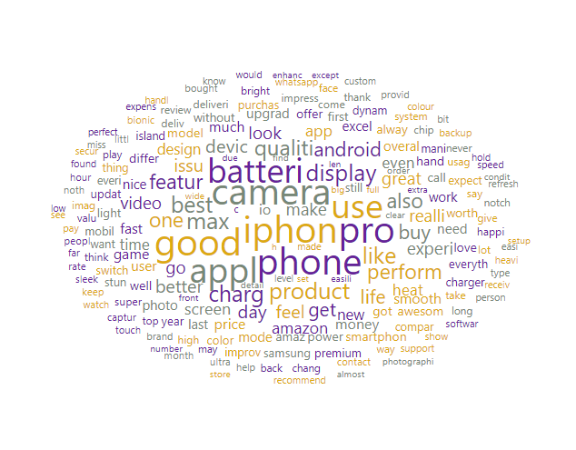  
*Figure 1: Word Cloud of iPhone Reviews*

The word cloud highlights the most frequently mentioned terms in the reviews, offering insight into key themes and concerns.

**Sentiment Analysis Scatterplot**

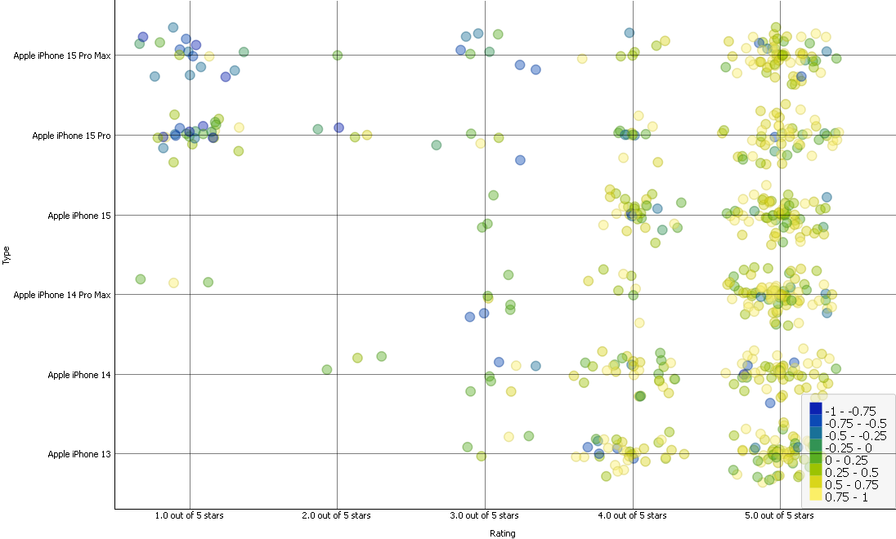

*Figure 2: Sentiment Analysis Scatterplot*

The scatterplot shows the distribution of sentiment scores across reviews, helping to identify overall sentiment trends.

**Linear Projection**

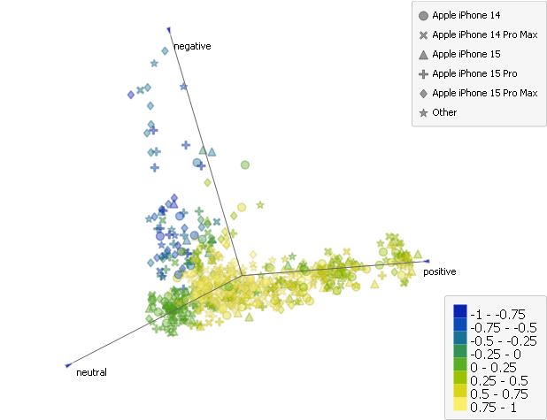  
*Figure 3: Linear Projection of Sentiment Data*

The linear projection provides a reduced-dimensional view of sentiment data, highlighting patterns and clusters.

**Radviz**

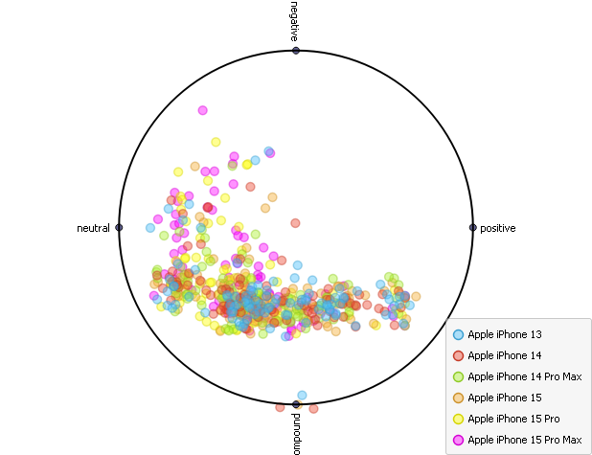  
*Figure 4: Radviz Visualization*

The Radviz chart visualizes the relationships between different sentiment scores, revealing how various sentiments are distributed across the dataset.

**Analysis and Findings**

* **Overall Sentiment**: The majority of reviews expressed positive sentiment, with some variation in negative and neutral sentiments.
* **Common Themes**: Reviews frequently mentioned specific features and performance aspects of the iPhone, as reflected in the word cloud.
* **Sentiment Distribution**: The scatterplot and linear projection reveal a generally positive sentiment with some clustering of negative reviews around specific issues.

**Conclusion**

The sentiment analysis provides a comprehensive view of customer opinions on iPhones. The visualizations created using Orange software effectively illustrate the sentiment distribution and highlight key themes in the reviews. This analysis can be useful for understanding customer satisfaction and identifying areas for product improvement.